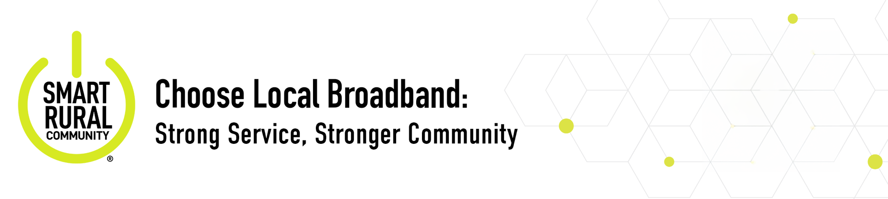
When you choose [DBA], you get reliable high-speed internet plus a partner invested in our rural community—not distant corporate priorities.
Local vs. National Provider: What’s the Difference?
[DBA] | National Provider
- Local support team. We know your name. | - Call centers.
- Nearby crews. Fast, responsive maintenance. | - Out-of-area techs.
- Sponsors local schools, nonprofits and events. | - Minimal or no local presence.
- Plans for homes, farms and small businesses. | - One-size-fits-all packages.
- Jobs and dollars stay in the community. | - Profits go to corporate HQs.
- Committed to rural digital growth and opportunity. | - Little community focus.

Smart Rural Community Commitment
As a Smart Rural Community program provider, [DBA] is dedicated to delivering top-tier broadband that powers local innovation, from telehealth and education to agriculture and economic growth—ensuring local broadband creates local impact.

We live here. We work here. We serve here.
Company
Logo
Investing in Our Community

Local Jobs
- [XX]% of staff live in the communities we serve
- Supporting [#] local businesses
Education
- Partnered with [School Name] to connect classrooms and students
- Supporting [STEM programs, internship, scholarships and esports teams]
Public Wi-Fi
- Free Wi-Fi in [libraries, parks, community centers]

LEARN MORE AT [COMPANY URL]

Digital Skills and Training
- [Workshops on digital literacy, remote work, AI, and online safety]
Economic Development
- Supporting economic activity, jobs and small businesses in our community
Events and Sponsorships
- Proud sponsor of [Community Event / Local Festival / Youth Sports]

